Let’s put a transitor in our breadboard:

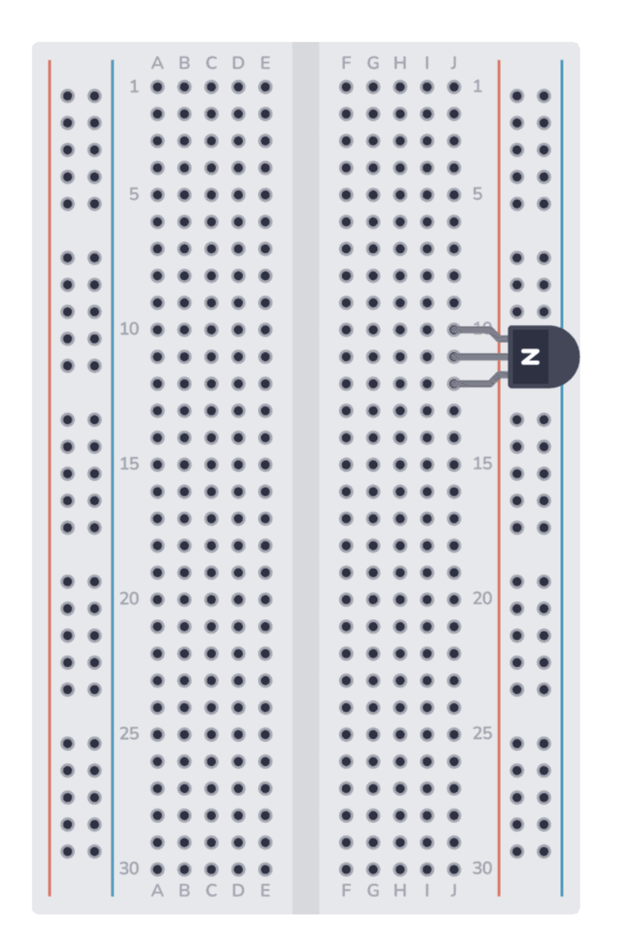

It’s a convention to put an N on the flat side face of a transistor in sketches like these, if the transistor is an NPN style.

NPN?
NPN stands for the structure of the transistor:
- N = Negative-type material (electrons do the work)
- P = Positive-type material (holes do the work—don’t worry about this yet)
- N = Negative-type material again

Imagine a Transistor Like a Magic Faucet

A transistor is like a magic faucet for electricity. It controls how much current flows through a wire, kind of like how a faucet controls the flow of water.

Now, a transistor has three legs (or pins):
- Collector – where the water (electricity) wants to come in
- Emitter – where the water exits
- Base – the control knob for the faucet

How an NPN Transistor Works (With a Metaphor)

Let’s say:
- You want to turn on a lamp (connected to the collector).
- The lamp is connected to positive voltage.
- The emitter is connected to ground (0 volts, where electricity drains out).

Now here’s the magic:
- The transistor will only let current flow from collector to emitter if you give a little squirt of current to the base.
- It’s like saying: “Hey transistor, here’s a little tap on your shoulder (base current), now open up and let the real current flow!”

In short:

An NPN transistor turns on when you give a little current to the base, allowing a much bigger current to flow from collector to emitter.

Why Use It?

It acts like a switch or an amplifier.
- Push a little signal into the base, and it lets a big signal flow through the other two legs.
- It’s how computers, radios, and amplifiers all control signals.

Step 2 – connect the resistor.
Note that it is not connected to any leg of the transistor:
